Flux Reconstruction Mapping

Example 1: Mapping of a physical element and its solution points (bottom figure) to the parent element (top figure).

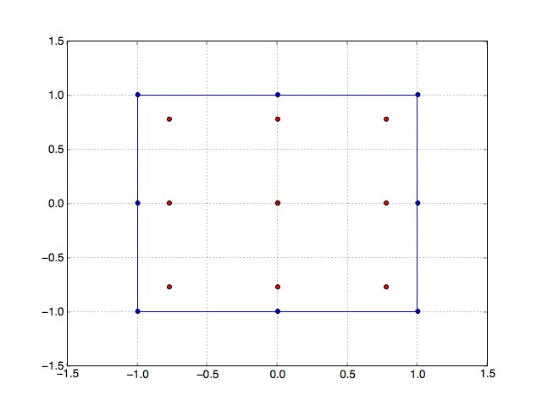

Figure . Parent Element and Gauss Solution Points. The blue points are the corner points of the element and the red points are solution points.

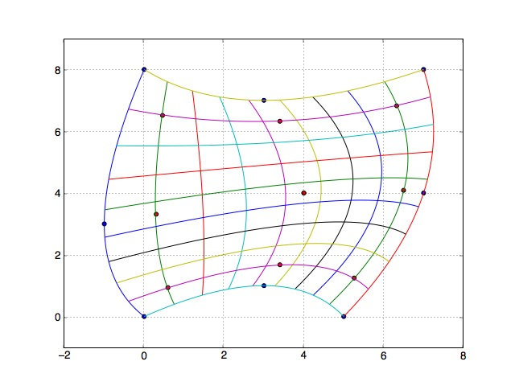

Figure . Physical Element and Mapped Gauss Solution Points. The blue points are the corner points of the element and the red points are solution points. Also shown are constant isoparametric lines from the mapping.

Example 2: Perturbed grid with mapped Gauss solution points.

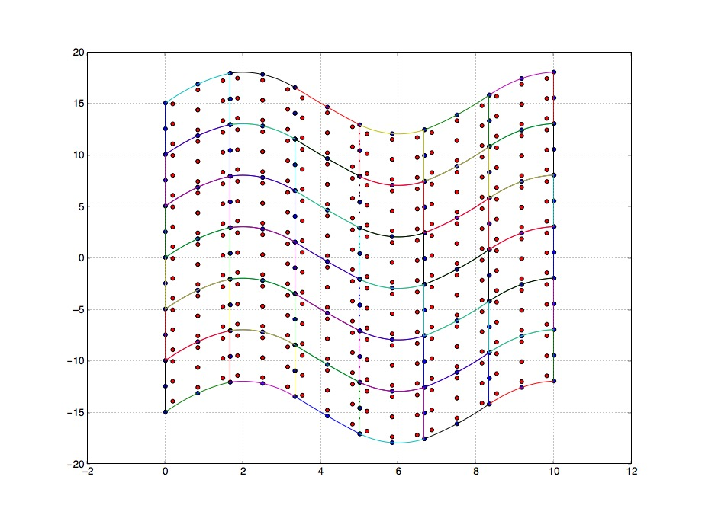

Figure . A 6 x 6 Grid. The blue points are the corner points of each element and the red points are solution points.

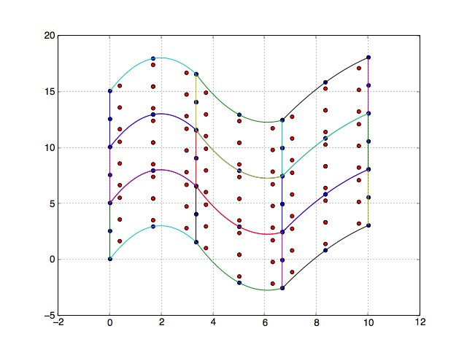

Figure 4. A 3 x 3 Grid. The blue points are the corner points of each element and the red points are solution points.